

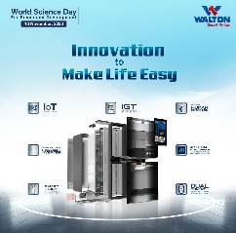

DHAKA SUNDAY NOVEMBER 24,2024

REGD.NO.DA.776 VOL.XXXIV NO.303 AGRAHAYAN 9,1431 BS JAMADIUL AWAL 21,1446 HIJRI



**934 hospitalised till this morning**

**P11**

**Grameenphone has unveiled a special** p5

# **Ban on battery-run rickshaws: Govt files petition seeking stay on HC order**

**The government has filed a petition with the Appellate Division of the Supreme Court seeking stay on a High Court order that asked to take steps to stop plying of their vehicles on the Dhaka roads.** "The stay petition has been filed yesterday afternoon. Its hearing will be held before the chamber judge of the Appellate Division this afternoon, " Deputy Attorney Nur Muhammad Azami told The Daily Star this morning. On November 20, the HC directed the government authorities concerned to take necessary measures to stop the plying of battery-run rickshaws and auto-rickshaws on the capital's streets within three days, aiming to reduce road accidents.

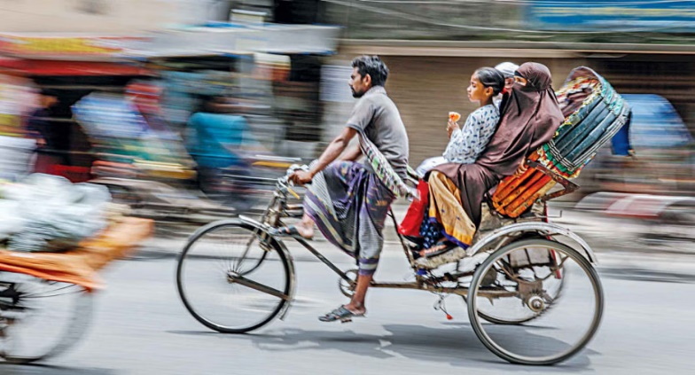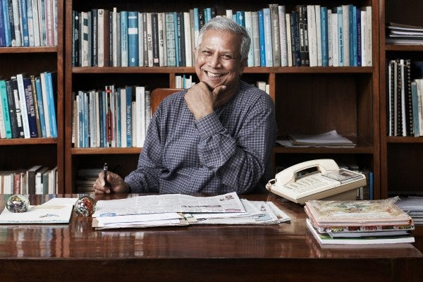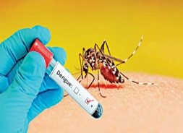

# **Dhaka's air quality 3rd worst in the world this morning**

The AQI in Bangladesh is based on five pollutants: particulate matter (PM10 and PM2.5), NO2, CO, SO2, and ozone.

Microsoft has stopped offering updates to Windows 11 B1

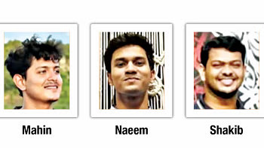

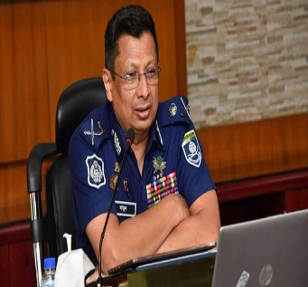

# **Ex-IGP Mamun on 3-day remand in murder case**

On August 21, the victim's brother Anowar

# **Deaths of 3 students: IUT declares 3-day mourning**

**Islamic University of Technology (IUT) has declared three days of mourning from today following**

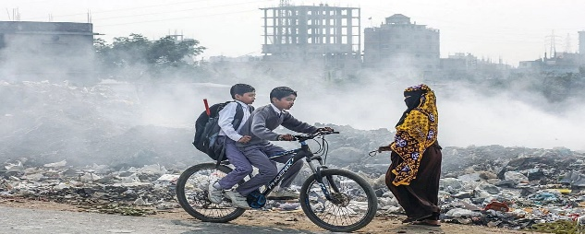

# **Three Zeros’ of Yunus a major catalyst for SDGs**

The vision of ["Three Zeros" of Dr Muhammad Yunus](https://www.thedailystar.net/op-ed/three-zeros-sustainable-world-111517), chief adviser to the interim government, can act as a major catalyst for achieving Sustainable Development Goals (SDGs), a speaker said at a recent workshop. "Let Bangladesh be an example of 'Three Zeros' to the future world," she said as the chief guest of a workshop on "Preparing VNRs: Reviewing Progress and Strengthening Partnership for SDG-17 in Context of LDC Graduation".The Economic Relations Division (ERD) organised the event in association with the Support to Sustainable Graduation Project at the National Economic Council in the capital on Monday, according to a press release.